Types of Instructions
Computers provide an extensive set of instructions to give the user the flexibility to carry out various computational tasks.
Most computer instructions can be classified into three categories:
1. Data transfer instructions
2. Data manipulation instructions
3. Program control instructions
Data transfer instructions
Data transfer instructions move data from one place in the computer to another without changing the data content.
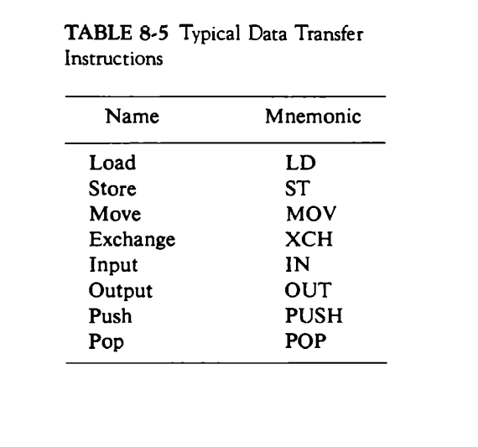
The load instruction has been used mostly to designate a transfer from memory to a processor register, usually an accumulator.
The store instruction designates a transfer from a processor register into memory.
The move instruction has been used in computers with multiple CPU registers to designate a transfer from one register to another.

The exchange instruction swaps information between two registers or a register and a memory word.
The input and output instructions transfer data among processor registers and input or output terminals.
The push and pop instructions transfer data between processor registers and a memory stack.
Data Manipulation Instructions
Data manipulation instructions perform operations on data and provide the computational capabilities for the computer.
The data manipulation instructions in a typical computer are usually divided into three basic types:
1. Arithmetic instructions
2. Logical and bit manipulation instructions
3. Shift instructions
Arithmetic instructions
The four basic arithmetic operations are addition, subtraction, multiplication and division.

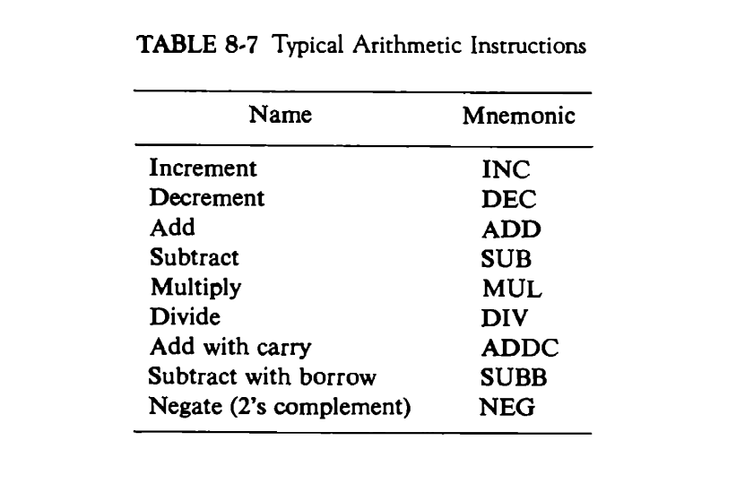
Logical and Bit Manipulation Instructions
Logical instructions perform binary operations on strings of bits stored in registers.

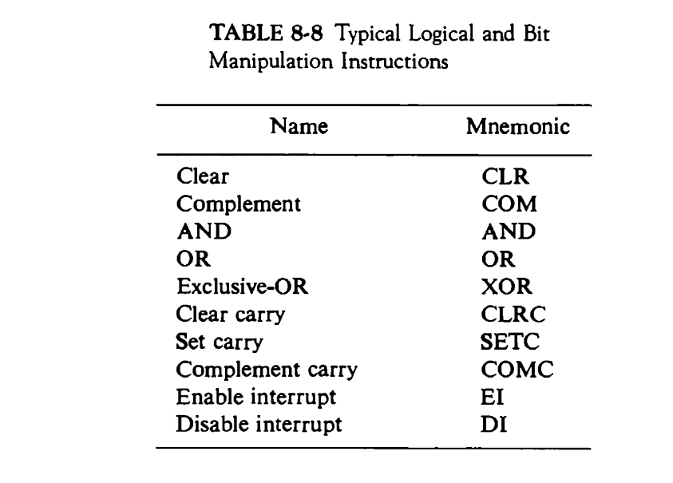
There are three bit manipulation operations possible: a selected bit can be cleared to 0, or can be set to 1 or can be complemented.
Flip-flop that controls the interrupt facility and is either enabled or disabled by means of bit manipulation instructions.
Shift instructions
Instructions to shift the content of an operand are useful. Shifts are the operations in which the bits of a word are moved to the left or right. The bit shifted in at the end of the word determines the type of shift used.

